PIZZA SALES SQL-QUERIES
A.KPI’
1.Total Revenue
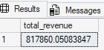
2.Average Order Value
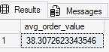
3.Total Pizza sold
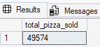

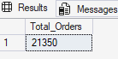
4.Total Orders

5.Average pizza per order
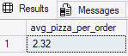

B.1.Daily Trend for Total Orders
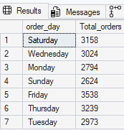

2.Monthly Trend for Total Orders
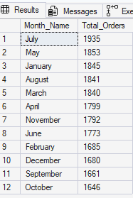
3.% of sales by category
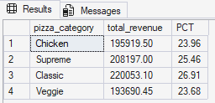

4.% of sales by pizza size
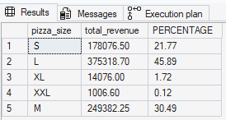
5.TOP 5 pizzas by Revenue
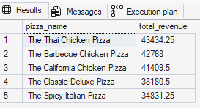
6.Bottom 5 pizzas by Revenue
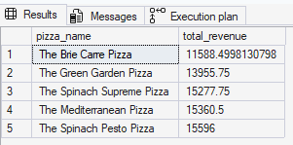
7.Top 5 pizza by Quantity
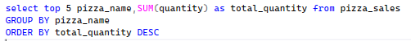
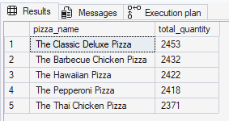
8.Bottom 5 pizzas by Quantity
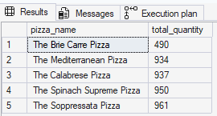

9.Top 5 pizza by Total order
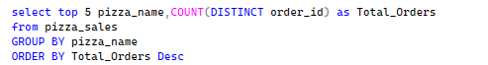
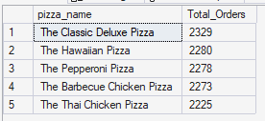

10.Bottom 5 pizza by Total Order
